Finding the evidence: using healthcare databases effectively to support your work

Creating a search strategy

Leeds Community Healthcare NHS Trust
Leeds & York Partnership NHS Foundation Trust
Leeds Teaching Hospitals NHS Trust
www.leedslibraries.nhs.uk
What are healthcare databases?

This guide will show you how to plan a search which you can then carry out in any appropriate database.

A “healthcare database” contains references, often with informative summaries or abstracts, to journal articles, guidelines, manuscripts, dissertations and book chapters. They cover every aspect of healthcare – from buildings and equipment through public health to social care to medicine and nursing and everything in between.

Where a full text copy of an article is available, a link will be displayed from the reference and you will be able to download the article.

Here is an example of a reference from one of the bibliographic healthcare databases. The way articles are presented on screen will differ from database to database but should always contain the same elements

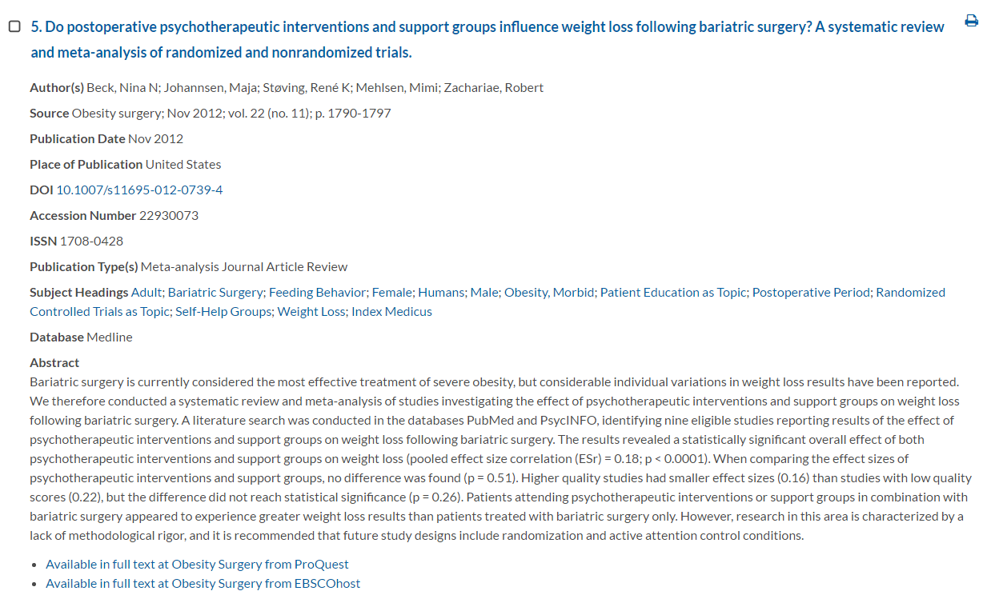

Plan your search

Before you begin searching, it is important to plan your search, giving some thought to what you are looking for and where you might find it. The more time you spend planning your search, the better your chances of finding relevant material.

The key steps in planning your search are:

- Define a clearly focussed question
- Identify the key terms for your search
- Identify which resources to use for your search

Example A - a question comparing two interventions

Step 1
Be specific and formulate a clear question
“Information about epidural analgesia in amputations” may become:
Is epidural analgesia more effective than hypnosis in reducing phantom limb pain in lower limb amputation?

Step 2
The PICO framework may be used to identify your key terms. PICO works really well for this type of question

Outcomes
Comparisons (if required)
Intervention or Exposure
Patient or Population

WHO?
Is the treatment or procedure being delivered to?

WHAT?
Is the condition or problem?

HOW?
Is the effect of the intervention or exposure measured?

WHAT?
Can be achieved?
WHAT?
Is the treatment or procedure being delivered?

WHAT?
Is happening to the patient or population?

HOW MUCH BETTER?
Is the procedure than another?

BETTER THAN WHAT?
What alternatives are there?

P – Patient / Population / Problem | Amputation
I - Intervention / exposure | Epidural analgesia
C - Comparison | Hypnosis
O - Outcome | Phantom limb pain

You may not need all four elements to construct your search; at least two should give some useful results.

Example B - a question about the effectiveness of one intervention

Step 1
Be specific and formulate a clear question

“Information about cognitive behaviour therapy and obesity” may become:
Are psychotherapy interventions effective in achieving weight loss in obese patients?

Step 2

PICO will work for this question as well but in this example ‘comparison’ is left blank. The researcher is not interested in a specific comparison.

Comparisons (if required)
Patient or Population
Intervention or Exposure
WHAT?
Is the treatment or procedure being delivered?

WHAT?
Is happening to the patient or population?
HOW?
Is the effect of the intervention or exposure measured?

WHAT?
Can be achieved?

HOW MUCH BETTER?
Is the procedure than another?

BETTER THAN WHAT?
What alternatives are there?
WHO?
Is the treatment or procedure being delivered to?

WHAT?
Is the condition or problem?

Outcomes

P – Patient / Population / Problem | Obesity
I - Intervention / exposure | Psychotherapy
C - Comparison
O - Outcome | Weight loss

PICO may well not work for the sort of question you are researching. There are a number of other frameworks you might want to consider:

ECLIPSE (Wildridge & Bell 2002)
Expectation – Client group – Location – Impact ‐ Professionals involved – Service
This framework is useful for questions relating to health policy and management issues. Expectation encourages reflection on what the information is needed for i.e. improvement, innovation or information. Impact looks at what you would like to achieve e.g. improve team communication.

EPICOT (Brown et al 2006)
Evidence – Population – Intervention – Comparison – Outcome – Timestamp
Designed to address research recommendations on the effect of treatments. In addition to the PICO elements, Evidence is for the current state of the evidence and Timestamp is for the date of the recommendations.

PECODR (Dawes et al 2007)
Population – Exposure – Comparison – Outcome – Duration ‐ Results
Useful for case control studies and cohort studies. Duration can be used to clarify the length of the follow up period and the Results could be used for Number Needed to Treat or similar.

PESTLE (CIPD 2010)
Political – Economic – Social – Technological ‐ Legal – Environmental
An analysis tool that can be used by organizations for identifying external factors which may influence their strategic development, marketing strategies, new technologies or organizational change.

SPICE (Booth 2006)
Setting (context) – Perspective– Intervention – Comparison – Evaluation
Useful for qualitative studies that seek to evaluate a service. Perspective relates to users or potential users. Evaluation is how you plan to measure the success of the intervention.

SPIDER (Cooke, Smith & Booth 2012)
Sample ‐ Phenomenon of Interest – Design (of study) – Evaluation ‐ Research type
Useful for qualitative or mixed methods research. Phenomenon of Interest includes behaviours and/or experiences e.g. compliance.

If you prefer not to be tied to any specific framework, or none of them fit with your type of question, you can simply break your question down into its separate discrete concepts, and then look at synonyms for those. The matrix on the next page may help you do that.

Step 3
Think about all of the resources that are available. Healthcare databases will not always be the most appropriate, or the only source for your query. You may need to look in a reference book or statistical publication, or news sources, or organisational documents..

Choose a database
The database you choose to start your search in should be based on the subject that you are searching for. You may need to search more than one to be thorough, so think about any others you will search later.
The major databases with which you may be familiar, and which cover health topics are:
Medical focus
EMBASE 1980 to present
With particular emphasis on European sources, this database covers the whole field of medicine. Drugs, pharmacology and substance abuse are particularly well covered using 5,000 journals about 1,500 not used in Medline.
- Access via Ovid

MEDLINE 1950 to present
This is a large database of medical information. Other subjects covered include dentistry, veterinary medicine, medical psychology, genetics and advanced nursing practice. The database covers over 5,000 journals from 70 countries.covers over 5,000 journals from 70 countries.
- Access via Ovid, Ebsco, or Proquest

Nursing/Therapy focus
Cumulative Index of Nursing & Allied Health (CINAHL) 1981 to present
A database covering all aspects of nursing and allied health. Subjects covered include optometry, radiologic technology, speech and language pathology, nutrition. Contains materials from over 1,200 journals, theses, and pamphlets. and pamphlets.
- Access via Ebsco

EMCARE 1995 to present
With a focus on nursing and the allied health professions, alongside medical and nursing education, and a broad range of other specialties. Details of articles from 3,700 journals including 2,800 not found in other nursing databases.
- Access via Ovid

British Nursing Index (BNI) 1985 to present
A focused database covering A&E, neonatal, cancer, theatres, orthopaedic nursing, etc. Details of articles from over 250 key English language nursing and midwifery journals. focused database covering A&E, neonatal, cancer, theatres, orthopaedic nursing, etc. Details of articles from over 250 key English language nursing and midwifery journals.
- Access via Proquest
- Access via Ovid

Allied and Complementary Medicine (AMED) 1985 to present
Covers occupational therapy, physiotherapy, rehabilitation, plus alternative medicine: acupuncture, chiropractic, homeopathy, yoga, hypnosis, etc. Indexes over 400 English and European journals.
- Access via Ovid

Focus on psychology and related aspects
PsycINFO 1806 to present
Subjects covered relate to clinical, social and biological areas of psychology. These include addiction, pharmacology, anthropology and law. Published by the American Psychological Association, material is included from 2,000 international periodicals.
- Access via Proquest

Management focus

HMIC 1979 to present
Comprises DH Data and Kings Fund databases both of which cover UK NHS health services management, policy and standards and social care. DH Data includes planning - financial, building and equipment; public health; toxicity studies on specific chemicals. The majority of DH Data records are from 1983 onwards, although coverage of departmental materials dates back to 1919. Kings Fund’s focus is on improvements in health and health care, covering health inequalities, partnership working and workforce development (1979 to date).
- Access via Ovid

Access to these major databases is provided via Ovid, Ebsco, or Proquest. Some databases can only be accessed through one provider e.g. PsycInfo must be accessed through Proquest. Other databases can be accessed through multiple providers – you can choose which one you prefer. Links to the different providers are available on LeedsLibraries.nhs.uk
However, these are not the only databases you may wish to search. The Leeds Libraries website has an A-Z of resources (https://www.leedslibraries.nhs.uk/resources/a-z-of-online-resources) which includes some subject specific and other databases such as:
Cochrane Library - major systematic reviews
PEDro - Physiotherapy
OTSeeker - Occupational therapy
Open Grey - material not published in the mainstream commercial journals

You should consider all these resources as possible avenues for your search.

Access

You will need an NHS OpenAthens username and password to use these databases. To register go to: https://openathens.nice.org.uk/. If you are on a trust network you will receive your username and password straight away.

The easiest way to get to any of the resources you might want to use is from the Leeds Libraries for Health website [https://www.leedslibraries.nhs.uk/resources/a-z-of-online-resources]

The NHS Leeds Libraries web pages http://www.leedslibraries.nhs.uk. Select Healthcare Databases from the Quick Links box. Enter your NHS Athens username and password in the LOG IN box. Click on the database name and the provider you wish to use.

Advanced Search is recommended. You will be able to control each step of your search to build a strategy with flexibility. More importantly, you can make use of the database’s own indexing thesaurus to construct a comprehensive and focussed search, tailored to your subject. It is advisable that you search in more than one database and that you search each database individually.

Free text searching

There are two approaches to searching the healthcare databases:

‘free text’ and ‘thesaurus’

Free text searching is simple and quick. You enter your term into the search box and click ‘search’. The database will show all of the records that contain your term.

It is important to be aware of the limitations of free text searching.
e.g. a free text search for “stroke” will retrieve the following article:

Can functional electric stimulation assisted rowing reproduce a race winning stroke? Archives of Physical Medicine and Rehabilitation 2004, Aug, Vol: 85 (8), P:1265-72

ü | BUT | x
Easy |  | No context to words searched/more irrelevant results
Quick |  | Need to think of all synonyms for a comprehensive search
Use your own terminology |  | Need to consider alternative spellings

Searching using the term ‘Psychotherap* ‘only retrieved references where the author refers to psychological interventions as psychotherapies (or a variant of the stem psychotherap*). References have not been retrieved where authors have used the name of specific therapies e.g. CBT, group therapy, family therapy etc. The same applies to the term ‘obesity’ and ‘weight loss’.

Sometimes there is no thesaurus term available, so a free text search is the only option, and you may need to be creative. There are tools to help make a free text search more effective, these are given in the table below. The tools vary depending on which provider you are using to access the database.

These tools will help optimise a free text search

Function and its symbol | Ovid | Ebsco | Proquest
Truncation  *  *n | Use * for unlimited right-hand truncation searches for variations on word endings.  Use *n to restrict the number of characters following the word. | Use *to find word endings. The asterisk can also be used within words to find multiple characters. | * retrieves variations of the search term. Use * at the end or in the middle of search terms. It replaces up to 5 characters.  Use defined truncation ([*n]) to replace up to 20 characters, with the number you want to use defined; for example [*9].
Phrase searching  “ ” | Multiple terms are presumed to be a phrase | Use quotation marks “ ” to search a phrase.  When searching a phrase, the default search order is that phrases are searched in the order in which they are typed in, with the words right next to each other. It is recommended that phrases be enclosed in quotations marks when included in searches. | Use quotation marks “ ” to search a phrase
Adjacency or Near  Adj | ADJn is a positional operator that lets you retrieve records that contain your terms (in any order) within a specified number (n) of words of each other. | Near Operator (N): N5 finds the words if they are a maximum of five words apart from one another, regardless of the order in which they appear. | NEAR/n or N/n Look for documents that contain two search terms, in any order, within a specified number of words apart.
Adjacency - with a defined word order | Not applicable | Within Operator (W): W8 finds the words if they are within eight words of one another, in the order in which you entered them. | PRE/n or P/n Look for documents that contain one search term that appears within a specified number of words before a second term.

Using Boolean operators

To combine searches we use Boolean operators. The most common Boolean operators are AND, OR and NOT.

Operator | What will happen to my search
AND | Narrows your search | Articles MUST include BOTH search terms to be included in your search results be retrieved.
OR | Broadens your search | Articles can include EITHER search term to be included in your search results. It does not matter which of the two is found.
NOT | Narrows your search | Articles can ONLY include the FIRST term and MUST NOT include the SECOND term to be included in your results.

Examples:

The area shaded is the information returned

Mattresses AND  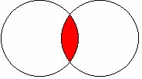  Pressure sores |  | This would return:  Articles about mattresses and pressure sores  This would not return:  Articles about mattresses only  Articles about pressure sores only
Mattresses OR  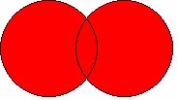  Pressure sores |  | This would return:  Articles about mattresses only  Articles about pressure sores only  Articles about mattresses and pressure sores
Mattresses NOT  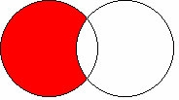  Pressure sores |  | This would return:  Articles about mattresses where pressure sores are not mentioned  This would not return:  Articles about pressure sores only  Articles about mattresses and pressure sores

Thesaurus searching

Each database is indexed by subject specialists who read the articles and assign subject terms to describe, as specifically as possible, the content of the article. The subject terms come from standardised lists of vocabulary and definitions, which are known as thesauri.

The idea behind the use of thesauri is that all the articles about the same concept are assigned the same subject heading, regardless of the words the author uses in his article.

Example: whooping cough and pertussis

Articles containing either of these terms are indexed under whooping cough, the thesaurus term for this disease.

Searching the Thesaurus

If you are doing a literature search using a healthcare database, but don’t know the correct term to use, you can search the thesaurus (this may also be called the subject headings).

Example: if you type in any of the following:
renal stones,  kidney stones,  renal calculi,  kidney calculi, | Searching the  Thesaurus points to | kidney calculi

Some databases have an American bias and as such some organisations, terminology or initiatives within the NHS that do not exist in the USA tend to be placed within the nearest American equivalent. If in doubt check the scope note.

Example: Clinical Governance does not exist as a subject.

Clinical governance | Searching the thesaurus  Thesaurus points to | Quality Assurance, Health Care

Select this subject and combine with a free text title and abstract search for the best results.

From the thesaurus, you can also:
• Major a search term - If you select major, then the thesaurus term will limit results to those where the selected term is (one of) the key topics being discussed. NB This may well exclude relevant articles, so should be used with caution.
• Explode a search term - Selecting to explode a term will include that term as well as any child nodes in your search.
• View Scope Notes - A lot of records include scope notes, which give important contextual information about the term. These can include information about what the term refers to, any related terms or further background information.
• View subheadings - Subheadings are a way of further refining a search based around a thesaurus term.

Troubleshooting

What to do if you don’t find what you are looking for.

Searching for literature can occasionally lead to unsatisfactory results. There are generally two types of problem that may be encountered:
- Too many irrelevant articles in the search result
- Too few relevant articles generated by the search.
Ideally when carrying out a literature search the results should find all of the articles which are relevant to the question, while excluding any article which is not relevant.

Too Many Irrelevant Articles

If the search results contain a large amount of irrelevant articles try:
- Looking at relevant articles that you have found to see what search terms they used, then amend your search using these.
- Using the Limits, such as limit to geographical location, age group,
- Limiting the date of publication range.
- Using the NOT command to exclude a concept which is not wanted. Use only if results have a strong bias towards a topic that you do not want at all as you may remove some useful information.

Not Enough Useful Articles

If the search results do not contain enough useful articles try:

- Looking at relevant articles that you have found to see what search terms they used, then amend your search using these.
- Searching in an alternative database.
- Widening your search – your search may contain too many subjects. Try removing one of the search terms or limits.
- Using the OR command, For example ‘wound care’ OR ‘wound management’
- Try using free text searching (i.e. looking for the words in the title and abstract) in conjunction with your Thesaurus search.

If you are searching for results in a new area of research there may be few published articles.

Need some support? Or want to know more?

To build on your knowledge after this course, more in depth training is available where you can:

Receive support to apply search skills to your particular topic
Learn about more functions of the database
Get help if your search isn’t giving you the information you need

To book a one-to-one session or get help and support for database searching, please contact your local Library Services Team.

Details available from www.leedslibraries.nhs.uk

Leeds Community Healthcare NHS Trust
Leeds & York Partnership NHS Foundation Trust
Leeds Teaching Hospitals NHS Trust

